HAG - UX design annotation

Avg Font size: 12

Colour Scheme  
Primary Colour: #FF3F72AF   
Secondary Colour: #FF112D4E



Font: Yu Gothic

Health Advice Group Logo.

The reset password allows for the user to reset the password.

Reset password

Placing the username box above the password box is a common convention in software design. This layout aligns with users' natural reading order (top to bottom) and follows a logical flow. It also emphasizes the importance of entering the username before the password, as the username typically precedes the password in the authentication process. This convention enhances user experience by aligning with expectations and established patterns.

Common conventions for the login button involve placing it below the username and password fields. This arrangement follows a natural progression, allowing users to input their credentials first before taking the action of logging in. Additionally, positioning the login button prominently, such as in the centre or bottom of the form, makes it easily accessible and noticeable. Using clear and concise labels on the button, like "Login," ensures users quickly understand the primary action they are about to take.

Redirects the user to the register page. Following the F pattern.

This logo is placed at the top left clearly. This can display clear branding, and this would go under a higher place on the hierarchy to display the brand visually and it can be easily recognisable to customers/clients

There is enough white space to edit the icons around and implement more features

This button should redirect the user back to the log in screen.

The register button should redirect the back to the log in screen which allows them to log back in again.  
If all the information entered is correct the user needs a message that will pop up saying the registration is successful and.

This should be the information the user needs to implement to register. Above the lines should be a box which allows the user to type the username, first name, last name, email address, password and confirm password. The boxes should be below the labels that describe what information should be entered.

The search bar should be able to look up a location (postcode, area, country, city town)

This should be able to tab through different screens on the same window each displaying a different page.

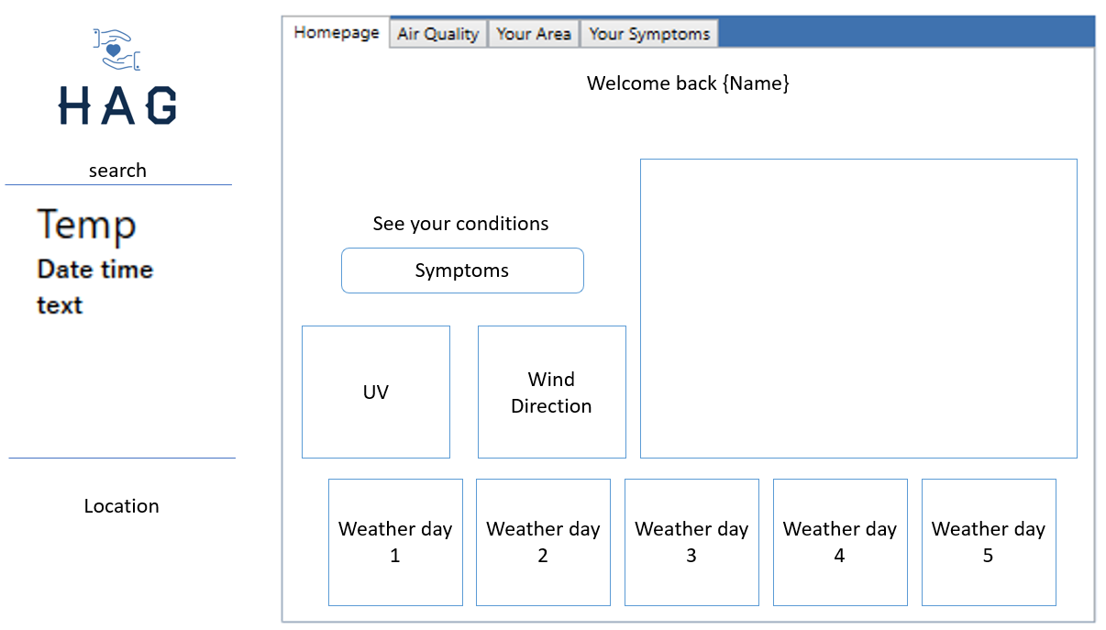

The search bar should be able to look up a location (postcode, area, country, city town)



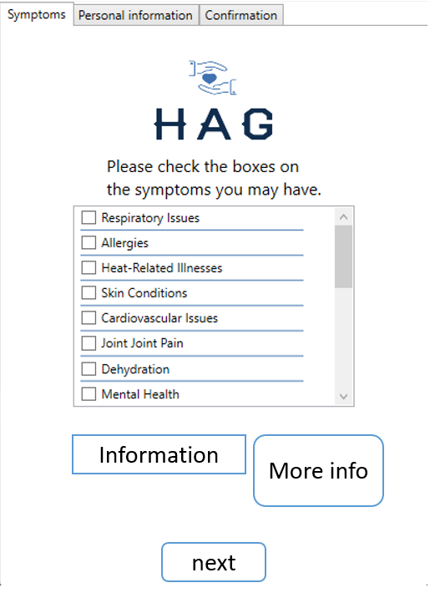

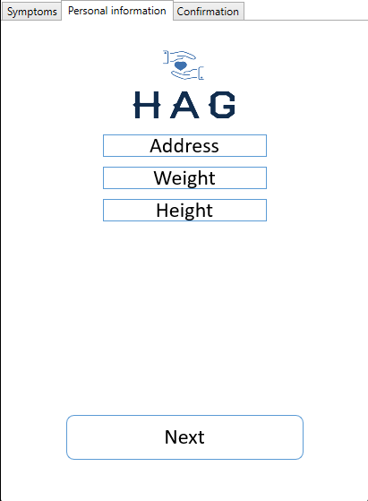

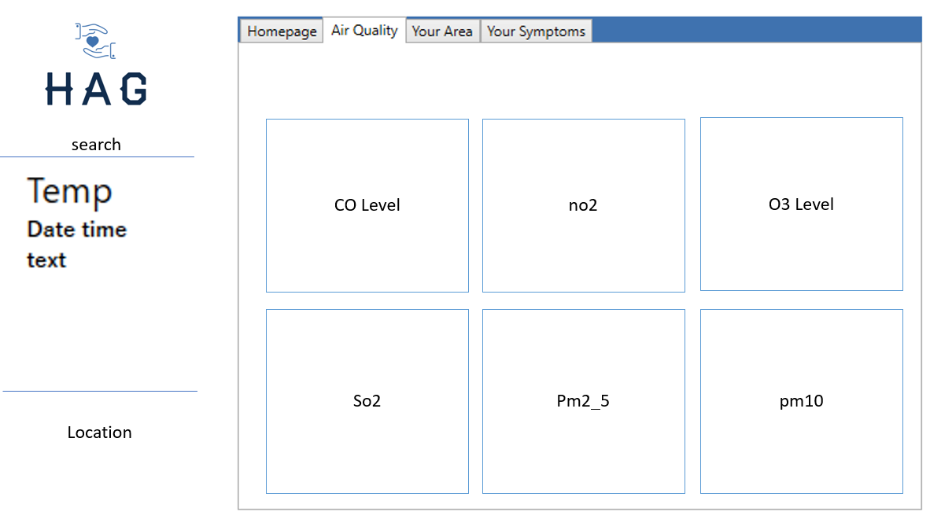

This should be able to tab through different screens on the same window each displaying a different page.

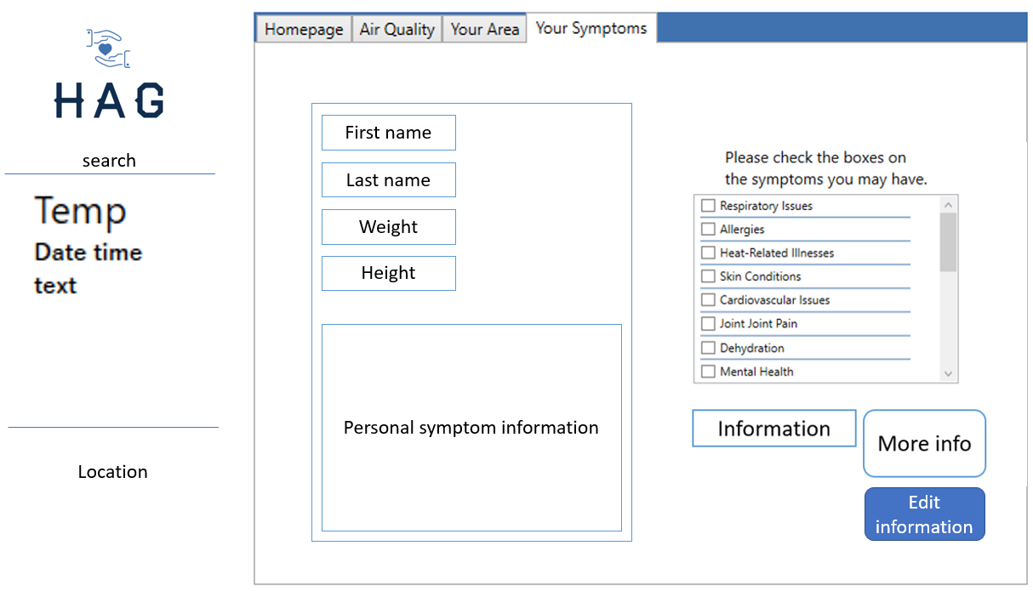 

This should be able to tab through different screens on the same window each displaying a different page.

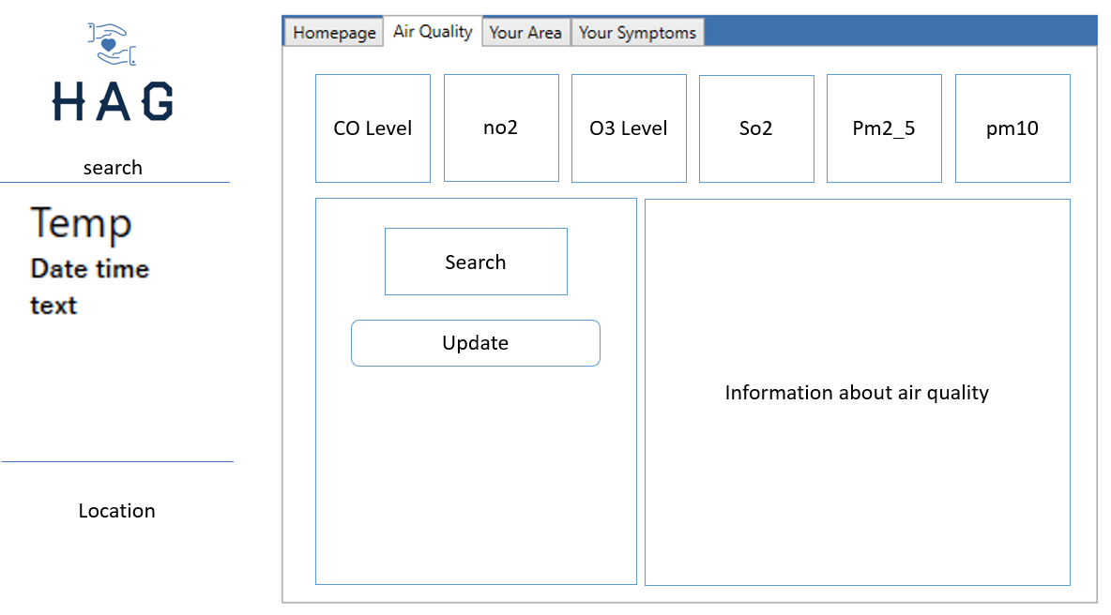

This should be able to tab through different screens on the same window each displaying a different page.